
NISSAN PATROL GU ULTIMATE FACTORY INTERCOOLED
[CALL US AT 08 8357 5993] 1100 SOUTH RD, EDWARDSTOWN SA

WARNING: Failure to follow this procedure will void your warranty.
• Do not use this product in any other motor vehicle for which it is not designed.
• Do not use any other mounting location / method other than described in this instruction.
• It is advisable to seek assistance of another person when installing this product.
• Do not repair or modify this product and / or its mounting bracket in any way - repair or modification may affect proper operation of the vehicle or cause destruction of property.
• Be sure to clean and remove any loose debris before removing pipe work as debris entering the engine could be detrimental to the engine and or components.

Please note the kits do not come with gaskets for the 2 adaptors. You will need to supply your own gaskets or use silicone sealer.
Remove sound deadening from the underside of the bonnet using a trim removal tool. Make sure to keep clips, disconnect the washer jet hose and then remove factory bonnet scoop from the car.
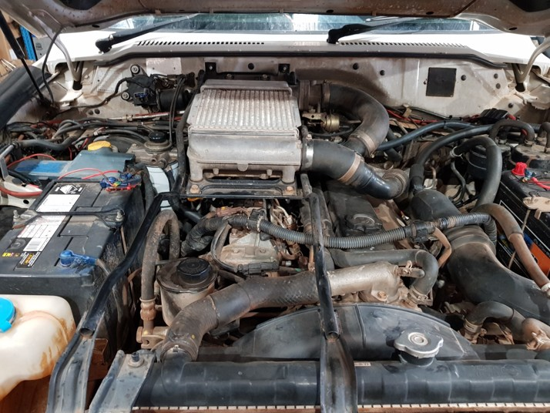
Remove the factory intercooler, intercooler frame, factory intercooler pipe work, cast pipe from the turbo outlet and EGR diaphragm pipe.

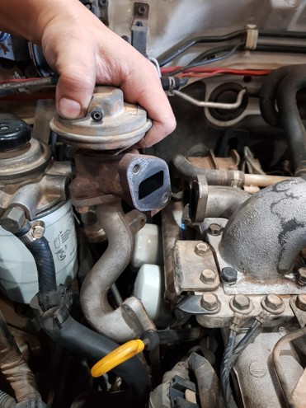

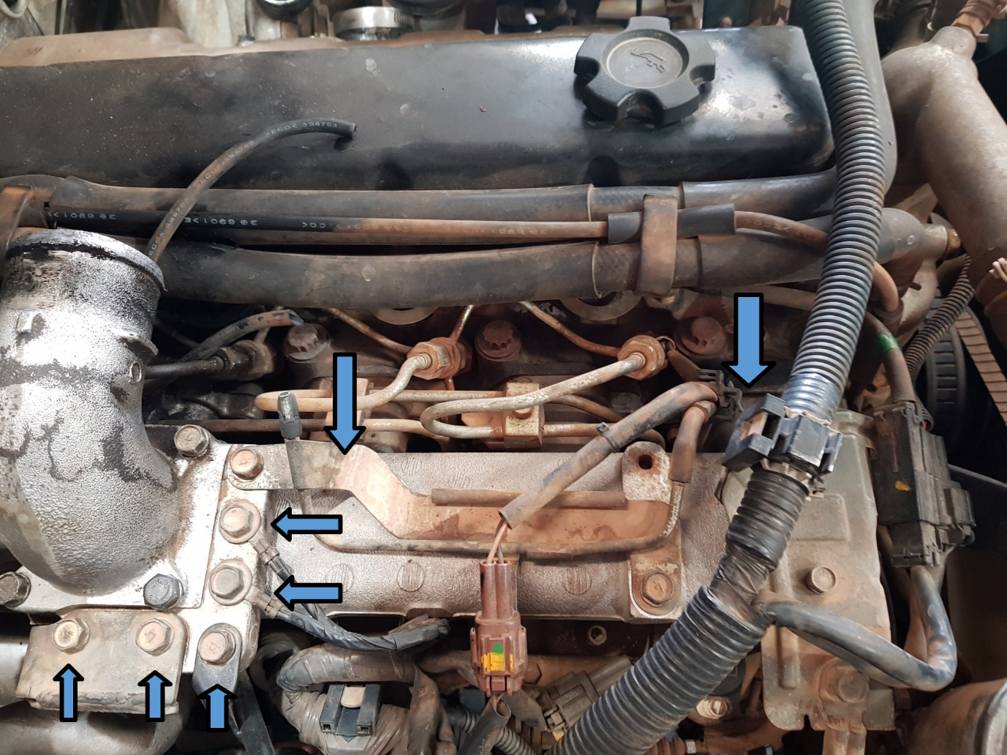
Unbolt earths, dipstick and EGR cooler bracket from the inlet adaptor then remove the inlet adaptor. Remove hardline and the bracket shown.
(The loom bracket may need to be bent to allow for clearance).

Fit the supplied EGR blank to EGR cooler using high temp silicone sealant. If the EGR cooler is being completely removed the blank can be used off the exhaust manifold.
PLEASE NOTE WE DO NOT SUPPLY ALL THE PARTS TO REMOVE THE EGR COMPLETELY!

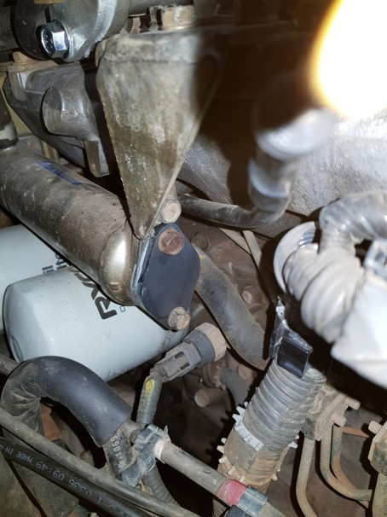

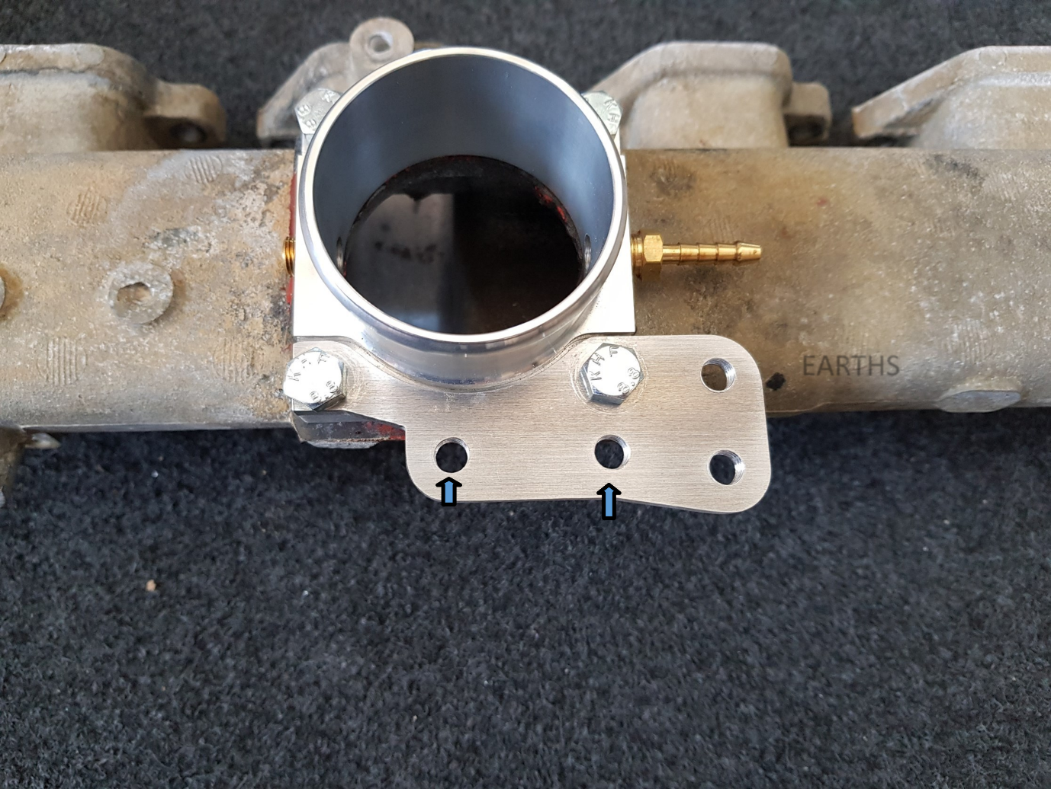

DIPSTICK

EGR COOLER BRACKET

Once installed re-attach the EGR cooler bracket, dipstick and earth cables. Run the vacuum line from the inlet to the boost compensator on the top of the fuel pump.
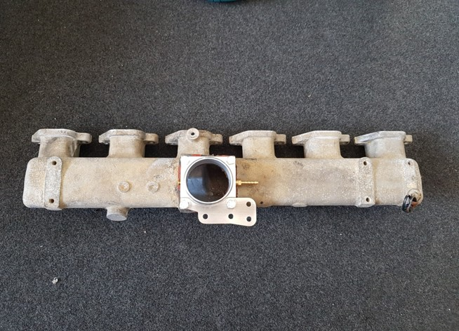
There is a spare port on the rear of the adaptor for a boost gauge, the thread is a 1/8th BSP.

The vacuum line connector location is on the top of fuel pump as shown below.
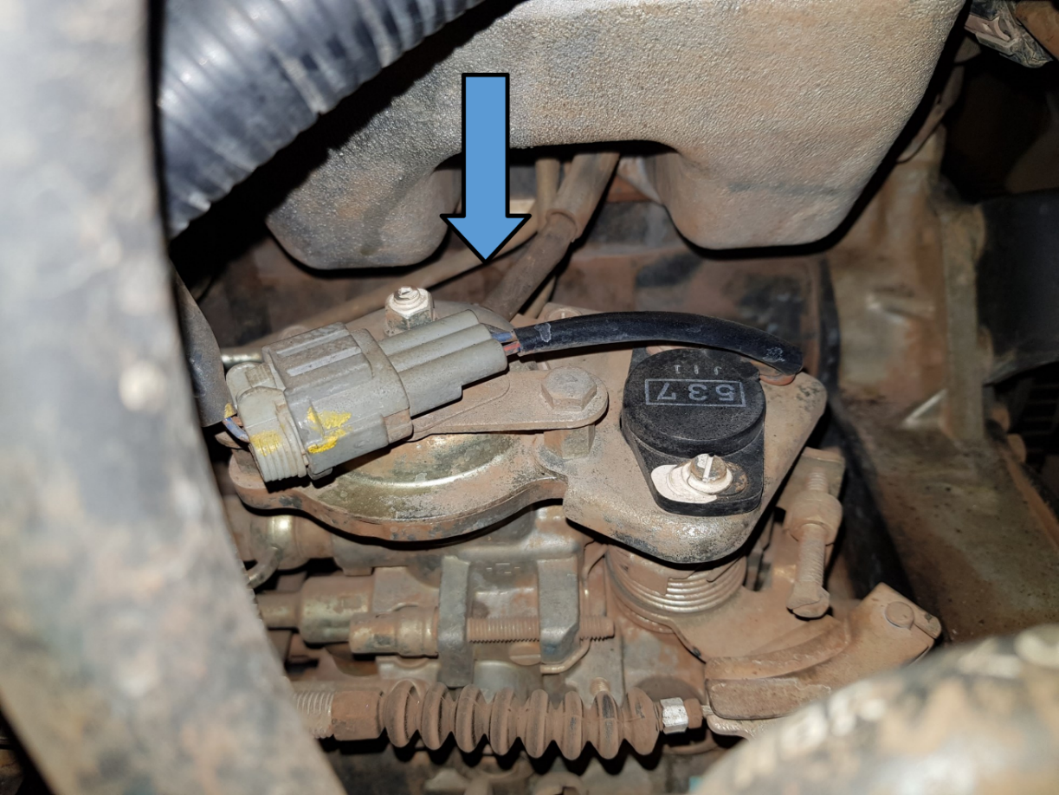
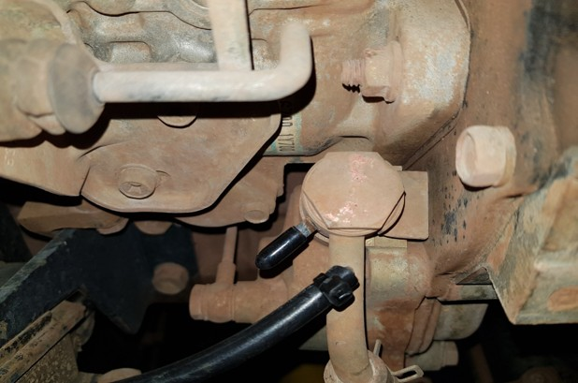
Use supplied hose blank to blank the line coming off the vacuum pump that was previously running to the EGR/Soft shut off solenoids.
The solenoids and vacuum lines for the EGR and soft shut down butterfly can now be unplugged and removed completely.
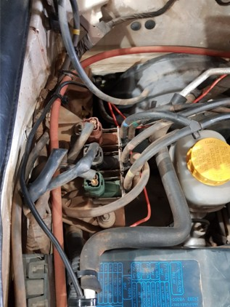

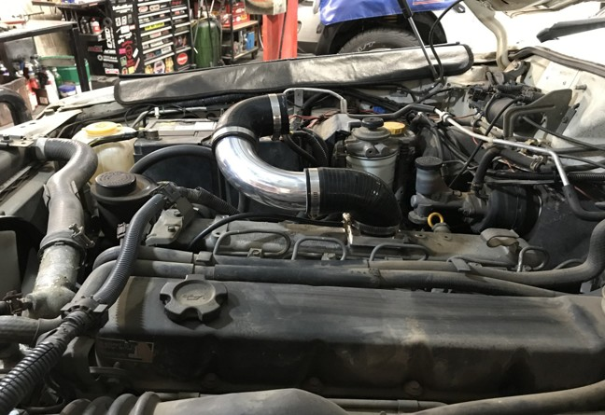

Fit the shortest silicone hose to the inlet adaptor positioning it at a slight downward angle as shown, then tighten the hose clamp.
Next, fit the 90-degree aluminium bend and the 90-degree silicone hose as shown. Fit the hose clamps, but do not tighten them yet.

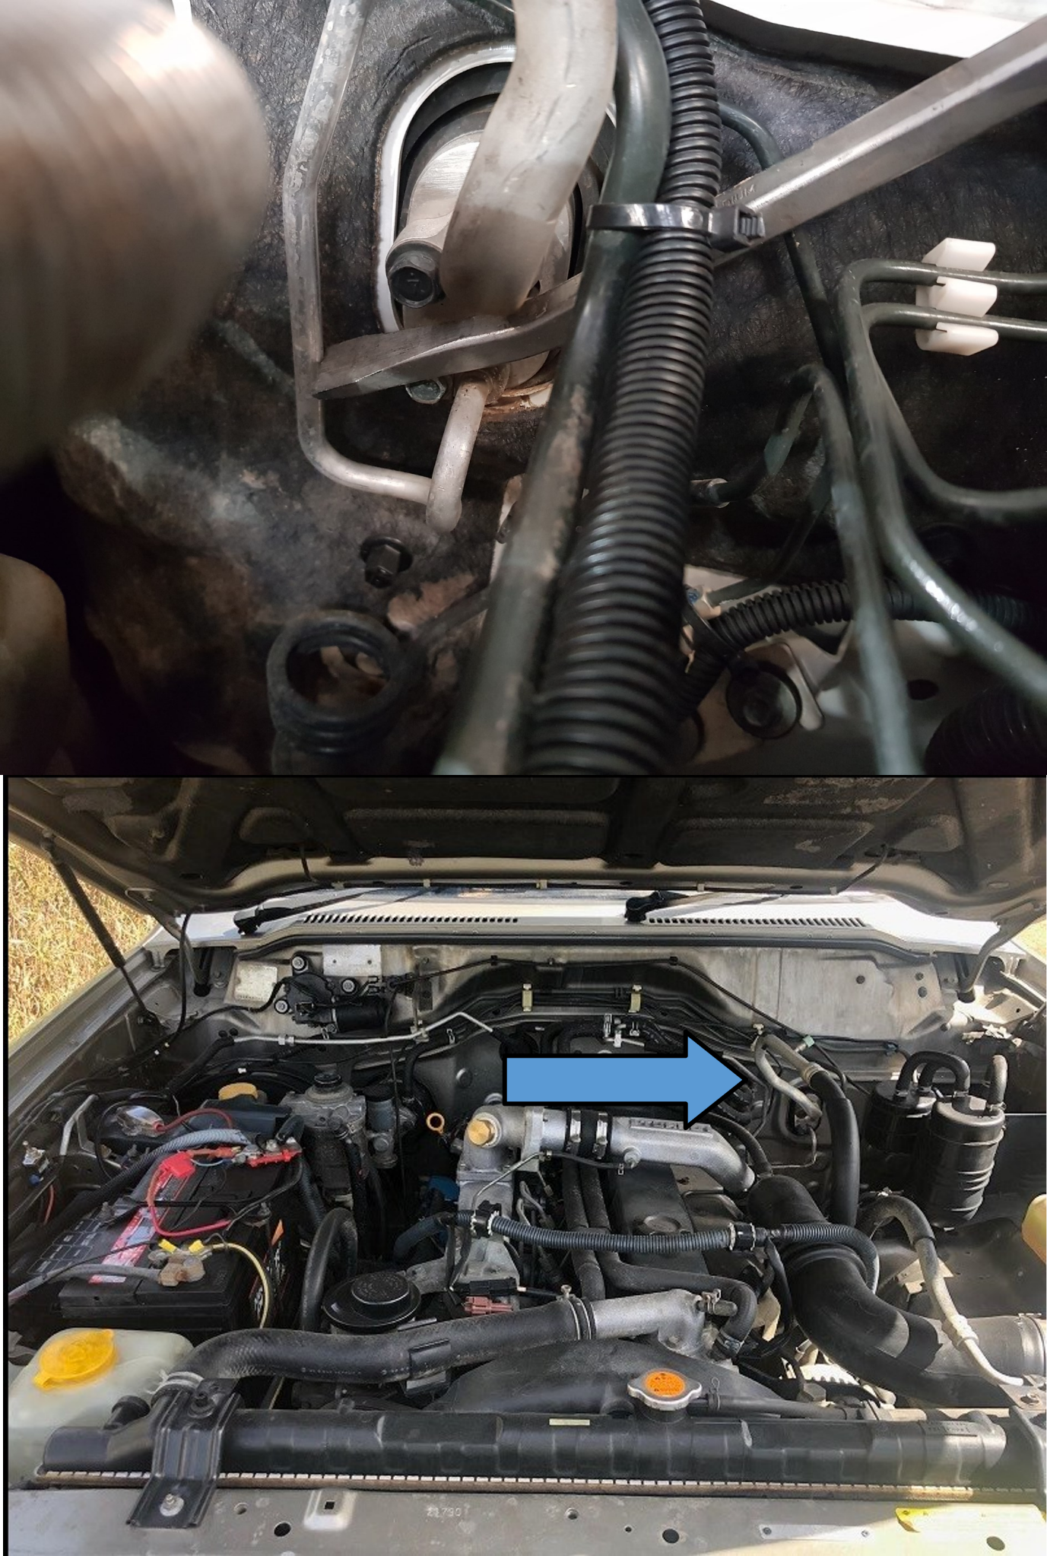

Using a pry bar as shown, support the A/C line at the firewall. Do not apply pressure directly to the pipe; position the pry bar against the connecting block.
Carefully move the A/C pipe toward the passenger side of the vehicle until sufficient clearance is achieved.
Note: The A/C line routing and configuration may vary between vehicle models. The vehicle shown may differ from your own vehicle.

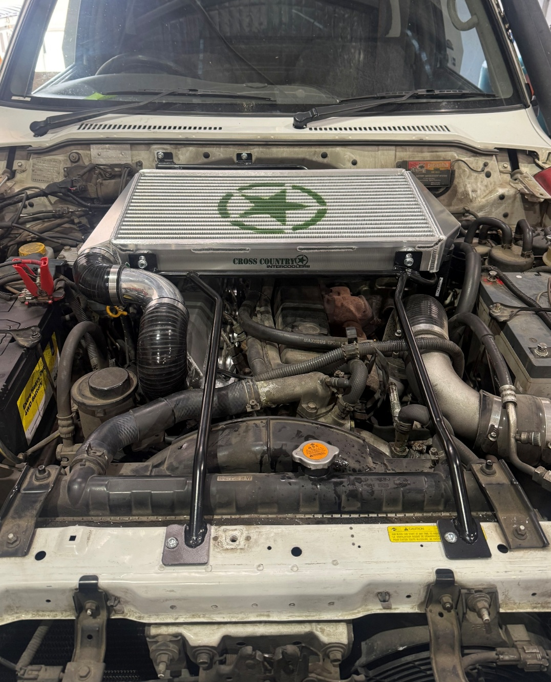

After adjusting the A/C lines, position the intercooler onto the two rear firewall studs and secure it using the supplied nuts. Tighten the nuts firmly.
Mark the locations of the two front mounting holes. Loosen the rear mounting nuts and carefully move the intercooler to one side to provide easier access for drilling.
Drill the two front mounting holes, taking care to avoid damaging any wiring, the A/C condenser, or other components behind the drilling area.
Tip: To help control the drilling depth, slide a small section of tube over the drill bit. The tube should be approximately 5–10 mm shorter than the exposed length of the drill bit. This provides a simple depth stop and helps prevent accidental damage to components behind the mounting surface.
Once drilling is complete, apply a suitable rust-prevention treatment to the exposed metal around the drilled holes.
Fit the 2” 45-degree silicone to the turbo adaptor with 2 hose clamps.
We recommend wiring our intercooler fans to an ignition source for example the wiper motor as a power supply.
Wire fan as below:
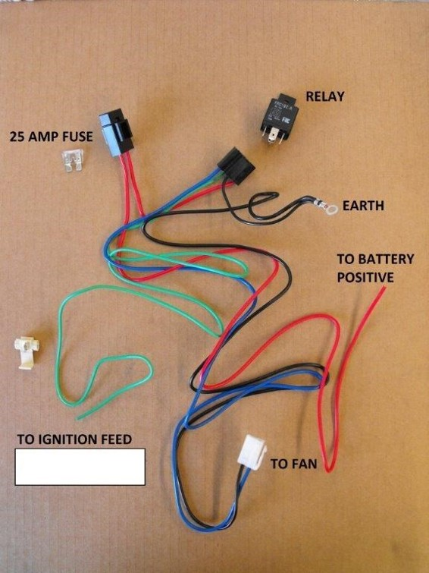

Check that the intercooler is level with the vehicle firewall. The 2-inch, 45-degree silicone hose can be used to support and raise the corresponding side of the intercooler. Apply gentle downward pressure to the intercooler as required to achieve a level position.
Once correctly positioned, tighten the rear mounting bolts and install and tighten the front mounting bolts.
Install the 90-degree silicone hoses as shown and tighten all hose clamps securely.
Finally, check that there is adequate clearance between the pipework and the underside of the intercooler. Ensure the pipework does not contact or rub against the intercooler or any surrounding components.
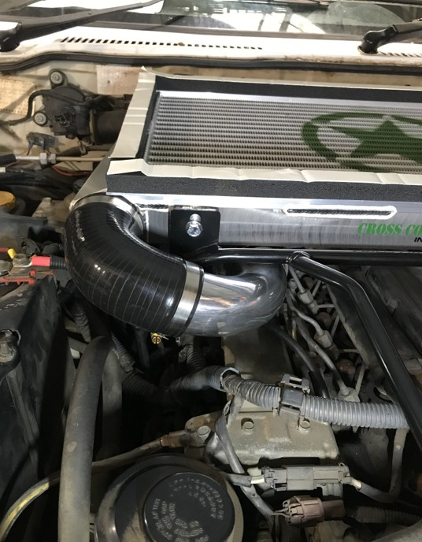

Once you’re ready to put your bonnet scoop on go to our website and under instructions select bonnet scoop, we have a separate file explain how to put your bonnet scoop on.

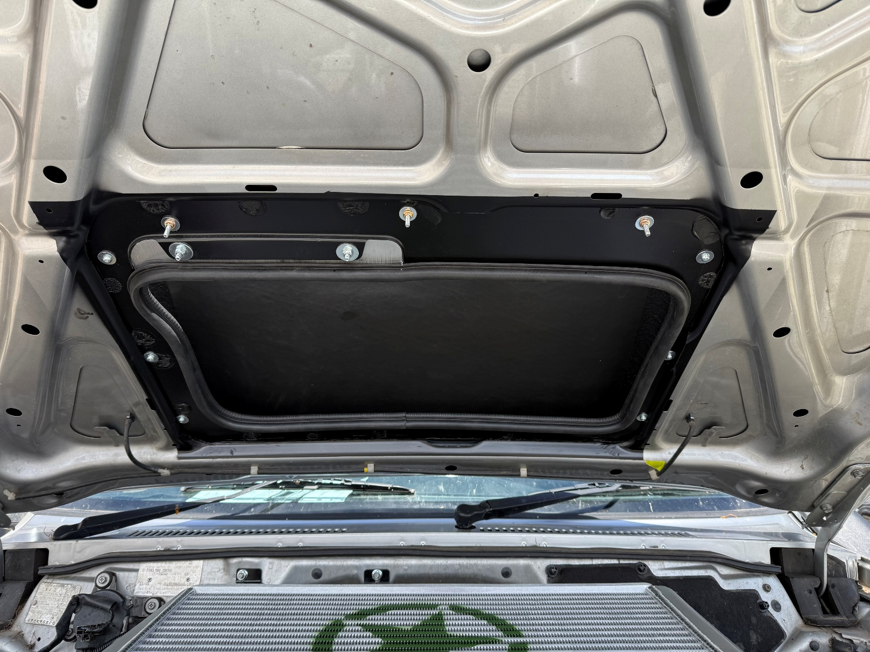
GU-PATROL-BONNET-SCOOP-FITTING-INSTRUCTIONS.pdf

